This can be done for all the values of k, packet arrival probability and Buffer size.

Following are some of the histograms got from the simulation:

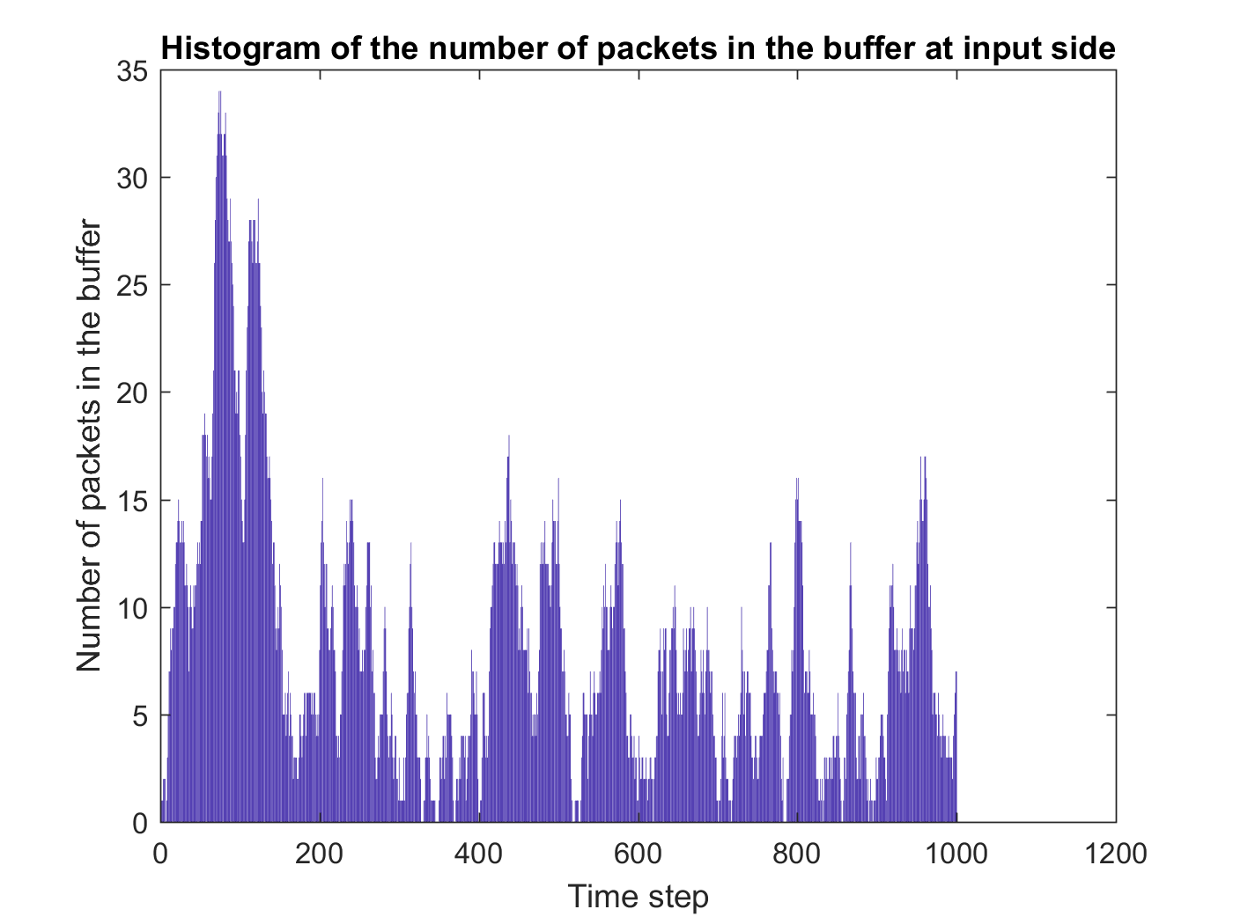

Balanced Traffic with probability of arrival of packets = 0.5 and Buffer Size = 10

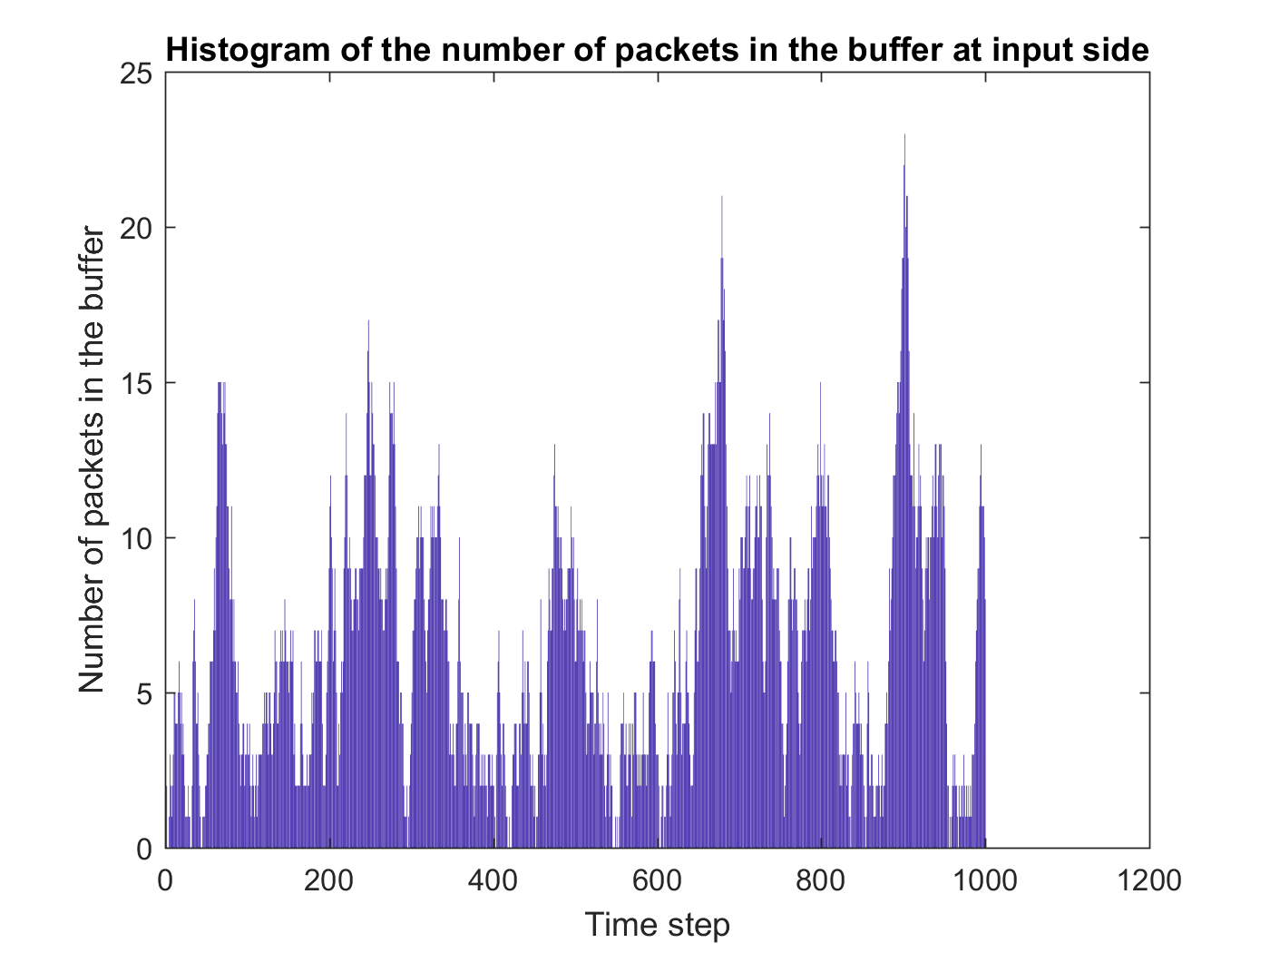

Balanced Traffic with probability of arrival of packets = 0.5 and Buffer Size = 20

A screenshot of a cell phone

Description generated with high confidence

Balanced Traffic with probability of arrival of packets = 0.6 and Buffer Size = 10

A close up of a logo

Description generated with very high confidence

Balanced Traffic with k = 2, probability of arrival of packets = 0.5 and Buffer Size = 10

A screenshot of a cell phone

Description generated with high confidence

Balanced Traffic with k = 2, probability of arrival of packets = 0.5 and Buffer Size = 20

A close up of a logo

Description generated with very high confidence

Balanced Traffic with k = 2, probability of arrival of packets = 0.6 and Buffer Size = 10

A screenshot of a cell phone

Description generated with high confidence

Balanced Traffic with k = 3, probability of arrival of packets = 0.5 and Buffer Size = 10

5. CODE

For Balanced Traffic,

close all;

clear;

clc;

prompt = 'What is the size of the switch?';

N = input(prompt)

prompt = 'What is the size of the buffer?';

B = input(prompt)

prompt = 'What is the arrival probability of a packet?';

Pa = input(prompt)

Buffer = zeros(N,B);

total = 0;

dropped = 0;

steps = 1000;

Ip = zeros(steps,1);

sum = 0;

for j = 1:steps

Hash = zeros(N,1);

for m = 1:N

x = rand;

if x < Pa

z = find( Buffer(m,:) == 0)

Z = isempty(z)

if Z == 0

Buffer(m,z(1)) = randi([1,N],1,1)

else

dropped = dropped + 1;

end

end

end

for m = 1:N

if Buffer(m,1) == 0

continue;

end

Hash( Buffer(m,1)) = Hash(Buffer(m,1)) + 1;

end

for m = 1:N

if Hash(m,1) == 0

continue;

end

Hash1(m,1) = randi([1,Hash(m,1)],1,1);

end

for m = 1:N

if (Buffer(m,1) == 0)

continue;

end

if (Hash1(Buffer(m,1)) == 0)

continue;

elseif (Hash1(Buffer(m,1)) == 1)

Hash1(Buffer(m,1)) = 0;

Buffer(m,:) = [Buffer(m,2:end),0]

total = total + 1;

else

Hash1(Buffer(m,1)) = Hash1(Buffer(m,1)) - 1;

end

end

Num = nnz(Buffer);

Ip(j,1) = Num;

sum = sum + Num;

end

figure;

bar(Ip);

title('Histogram of the number of packets in the buffer at input side');

xlabel('Time step');

ylabel('Number of packets in the buffer');

For Hot Spot Traffic,

close all;

clear;

clc;

prompt = 'What is the size of the switch?';

N = input(prompt)

prompt = 'What is the size of the buffer?';

B = input(prompt)

prompt = 'What is the arrival probability of a packet?';

Pa = input(prompt)

prompt = 'Enter value of k';

k = input(prompt)

Buffer = zeros(N,B);

total = 0;

dropped = 0;

steps = 1000;

Ip = zeros(steps,1);

sum = 0;

for j = 1:steps

Hash = zeros(N,1);

for m = 1:N

x = rand;

if x < Pa

z = find( Buffer(m,:) == 0)

Z = isempty(z)

if Z == 0

y = rand;

if y < 1/k

Buffer(m,z(1)) = 1;

else

Buffer(m,z(1)) = randi([2,N],1,1);

end

else

dropped = dropped + 1;

end

end

end

for m = 1:N

if Buffer(m,1) == 0

continue;

end

Hash( Buffer(m,1)) = Hash(Buffer(m,1)) + 1;

end

for m = 1:N

if Hash(m,1) == 0

continue;

end

Hash1(m,1) = randi([1,Hash(m,1)],1,1);

end

for m = 1:N

if (Buffer(m,1) == 0)

continue;

end

if (Hash1(Buffer(m,1)) == 0)

continue;

elseif (Hash1(Buffer(m,1)) == 1)

Hash1(Buffer(m,1)) = 0;

Buffer(m,:) = [Buffer(m,2:end),0]

total = total + 1;

else

Hash1(Buffer(m,1)) = Hash1(Buffer(m,1)) - 1;

end

end

Num = nnz(Buffer);

Ip(j,1) = Num;

sum = sum + Num;

end

figure;

bar(Ip);

title('Histogram of the number of packets in the buffer at input side');

xlabel('Time step');

ylabel('Number of packets in the buffer');